Report of A4

Liyang Ru

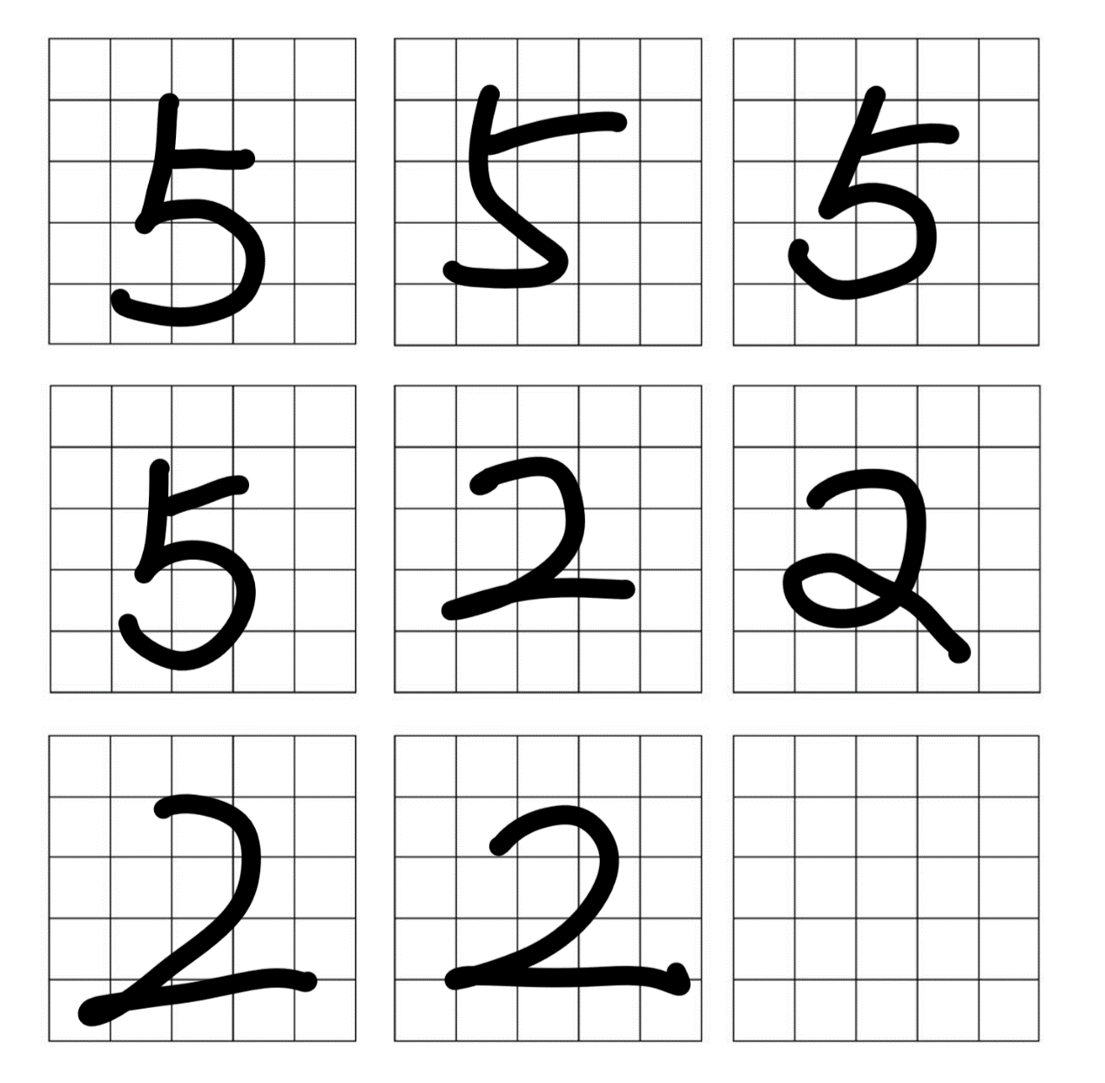Part1.

Part 2.

**● How accurately did your network classify the digits? ​You may use percent accuracy as the metric since the classes are evenly balanced.**

The accuracy is always vey low. It often ranges from 0.125 (12.5%) to 0.5 (50%). Since the retrieve function is randomly choose the order of lines in the matrix, so it is not stable.

**● If it is making errors, analyze the results in order to understand where the Hopfield network is making errors and explain them in your report. If it is not making errors, then discuss why it is classifying perfectly.**

It makes a lot of errors. I think there are several reasons:

1. The grid is too few (only 25 grids to describe the picture). It can’t describe the picture very accurately. For the example, I draw the first “5” like this:

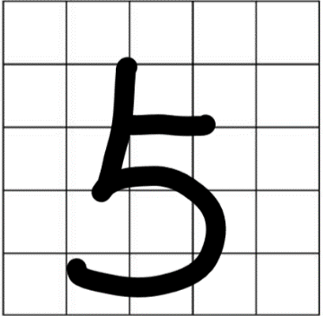

But after I change it into binary string, I visualize the string into this:



So 25 grids and algorithm of changing the picture to binary string cannot reflect the picture information correctly. We need more grids to reflect the picture.

1. My test data is really bad. The numbers I draw is not fully occupies the grids.
2. In the retrieve function, it randomly generates the order of the lines to product with the input pattern. So the accuracy of retrieve is unstable.
3. The size of training data set and testing data set are too small.

Part 3.

**● How accurately did your network classify the digits?**

The accuracy often ranges from 0.25 (25%) to 0.75 (75%) .

**● If it is making errors, analyze the results in order to understand where the MLP is making errors and explain them in your report. If it is not making errors, then discuss why it is classifying the data perfectly.**

It makes a lot of errors. I think there are several reasons:

1. The grid is too few (only 25 grids to describe the picture). It can’t describe the picture very accurately. 25 grids and algorithm of changing the picture to binary string cannot reflect the picture information correctly. We need more grids to reflect the picture.
2. My test data is really bad. The numbers I draw is not fully occupies the grids.
3. The algorithm of MLP has some random factor.
4. The size of training data set and testing data set are too small.

Part 4.

**● Produce a line plot, with classifier accuracy on the y axis, and distortion rate on the x axis. Your line plot should have two lines, one for your hopfield network and one for your MLP.**

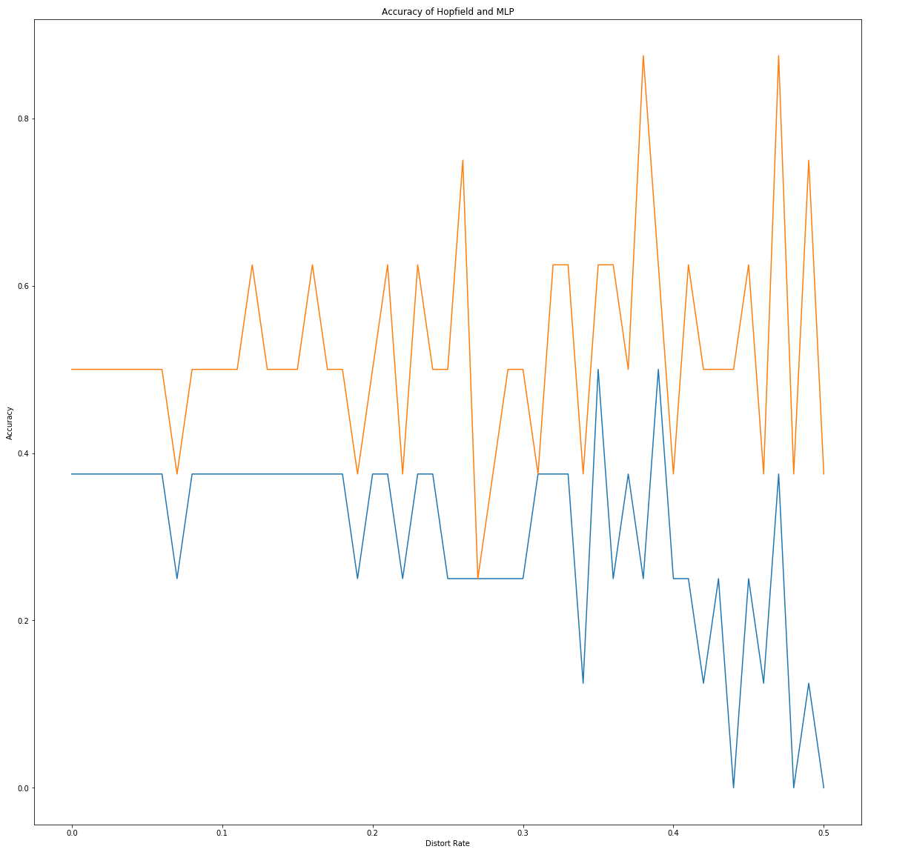

The blue line is Hopfield Network and the orange line is MLP.

**● Provide a brief (1 to 2 sentences) commentary on your graph. What does this data tell you about the two methods robustness to distortion.**

The accuracy of MLP is generally higher than that of Hopfield. As the rate of distortion increasing, the accuracy of both algorithms become less stable, the standard deviation will be larger. As the probability of distortion increasing, it may become more likely or less likely to retrieve and get the right memory.

Part 5.

● Report the results from your experiments with number of layers. Specifically, reproduce the graph from Part 4, but now with an additional line for different versions of your MLP (You still need to include the graph from Part 4 separately in your report). Briefly discuss your findings.

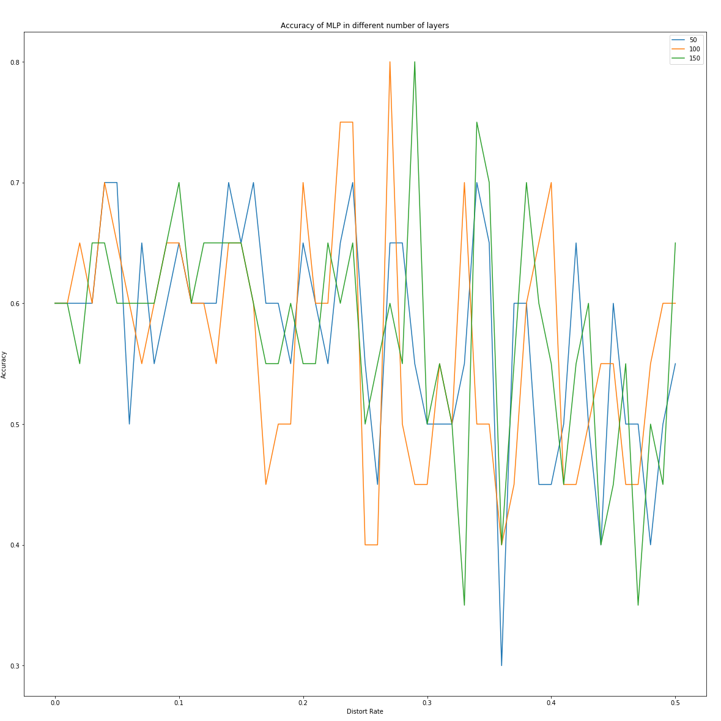

I changed the number of layers with different numbers: 50, 100 and 150 (you can find the corresponding line according to the legend on the graph). I cannot find any changes with changing number of layers (the parameter in MLP). I think the number of layers does not affect the performance of MLP a lot in this case. We can only improve the performance by get more better training data.